Billing Application tests

By: Farzaneh

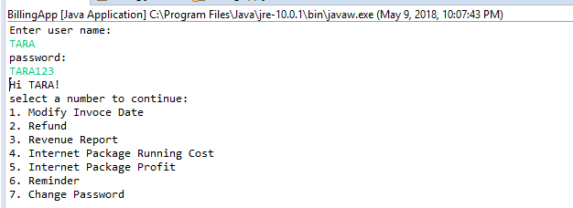

Option 1.

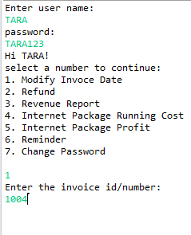

Invoice_Modification table before:

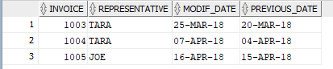

After date modification:

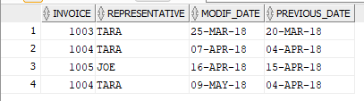

OPTION 2

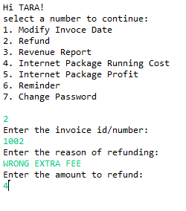

INSERT NEW RECORD IN REFUND:



INSERT NEW RECORD IN INVOCE_MODIFICATION



OPTION 3

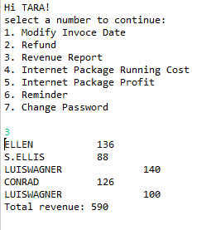

OPTION 4

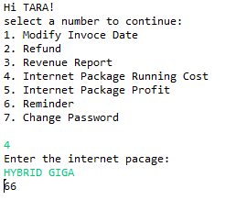

OPTION 5

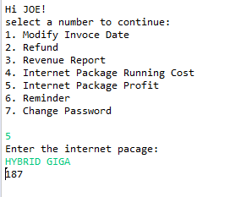

OPTION 6

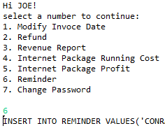

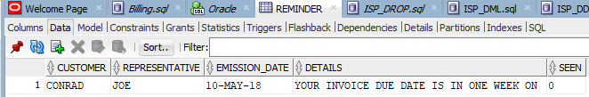

OPTION 7

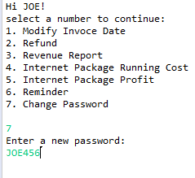

Joe’s new password with hash

